


Smart Parking System for Smart Cities

Prepared For
Smart-Internz Cybersecurity

By
Vighnesh Jaysing Sangavakar
D Y Patil Agriculture and Technical University, Talsande

On
22-06-2026

ProjectOverview
This project is an IoT-based Smart Parking System designed to improve parking space utilization, reduce vehicle search time, minimize traffic congestion, and support smart city initiatives. The system integrates a Python IoT Agent, Node-RED cloud workflow, IBM Watson IoT Platform, Cloudant Database, and a modern web dashboard for real-time parking management.

1. Introduction

Urbanization has significantly increased the number of vehicles on roads, leading to parking shortages and traffic congestion in cities. Drivers often spend considerable time searching for available parking spaces, resulting in fuel wastage, increased pollution, and frustration. The Smart Parking System leverages Internet of Things (IoT) technology, cloud computing, and real-time data analytics to provide an efficient parking management solution. The system enables users to monitor parking availability, reserve slots remotely, and receive real-time updates, thereby enhancing urban mobility and supporting smart city development.

2. Objectives

- Optimize parking space utilization through intelligent slot management.
- Reduce vehicle search time by providing real-time slot availability information.
- Minimize traffic congestion caused by vehicles searching for parking.
- Enable remote reservation and cancellation of parking slots.
- Provide real-time parking status monitoring through a web dashboard.
- Improve security and transparency in parking operations.
- Generate parking analytics for efficient decision-making.
- Support smart city initiatives through IoT-based infrastructure.

3. System Architecture

The proposed system follows a cloud-based IoT architecture consisting of four layers:

a) Sensing Layer

- Parking sensors monitor slot occupancy.
- Gate sensors detect vehicle entry and exit.
- Real-time data collection from parking spaces.

b) Communication Layer

- Data transmission through IBM Watson IoT Platform.
- Secure communication using MQTT protocol.
- Continuous synchronization between devices and cloud services.

c) Processing Layer

- Node-RED processes incoming events.
- Business logic for reservations, occupancy updates, and notifications.
- Cloudant Database stores historical parking records.

d) Application Layer

- Web dashboard for monitoring and control.
- Visualization of parking analytics.
- User interaction for booking and managing parking slots.

4. Technologies Used

Technology | Purpose
Python | IoT Agent development and simulation
IBM Watson IoT Platform | Device management and communication
Node-RED | Workflow automation and event processing
Cloudant Database | Storage of parking records
| HTML5 | Dashboard structure
CSS3 | User interface styling
JavaScript | Dynamic dashboard functionality
MQTT Protocol | IoT device communication
WiOTP SDK | IBM Watson IoT integration

5. Working of the System

The parking area consists of six parking slots labeled A1 to A6. Each slot is monitored by sensors that detect vehicle occupancy.

- When a vehicle enters the parking lot, the entry gate opens automatically.
- The corresponding parking slot status changes from Available to Occupied.
- The Python IoT Agent sends occupancy data to IBM Watson IoT Platform.
- Node-RED receives and processes the data.
- Parking events are stored in Cloudant Database for future analysis.
- Users can view available slots through the web dashboard.
- Reserved slots are marked separately to prevent unauthorized occupancy.
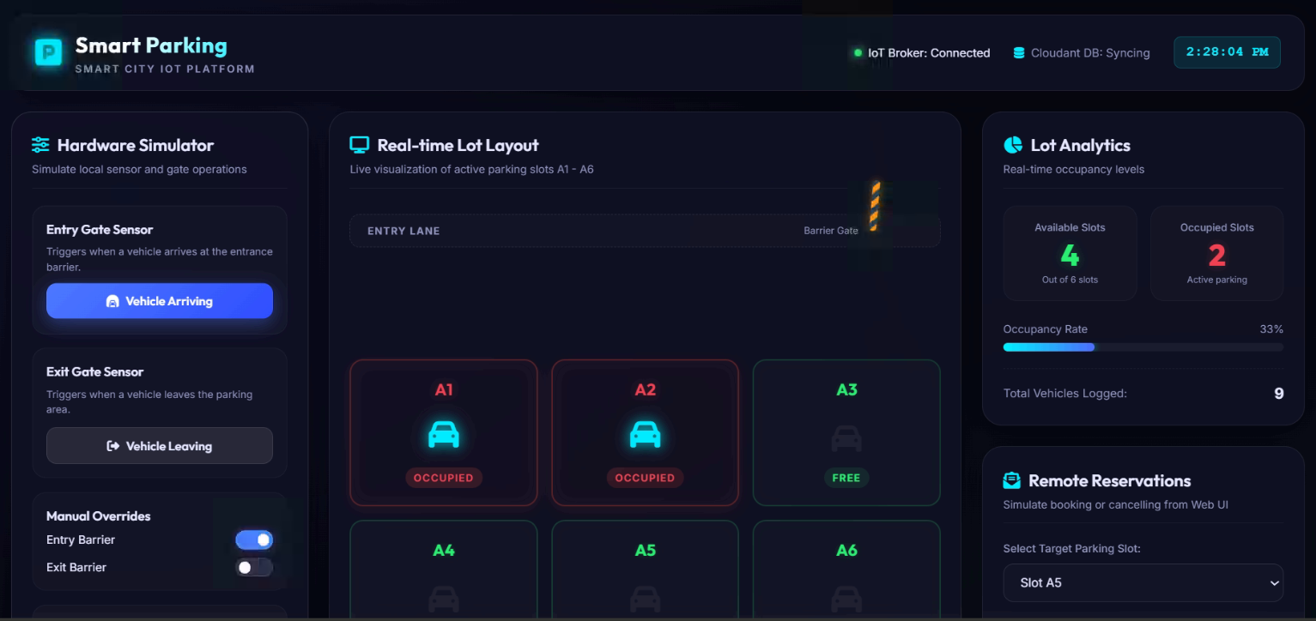
- Upon vehicle exit, the slot becomes available again and occupancy statistics are updated in real time.

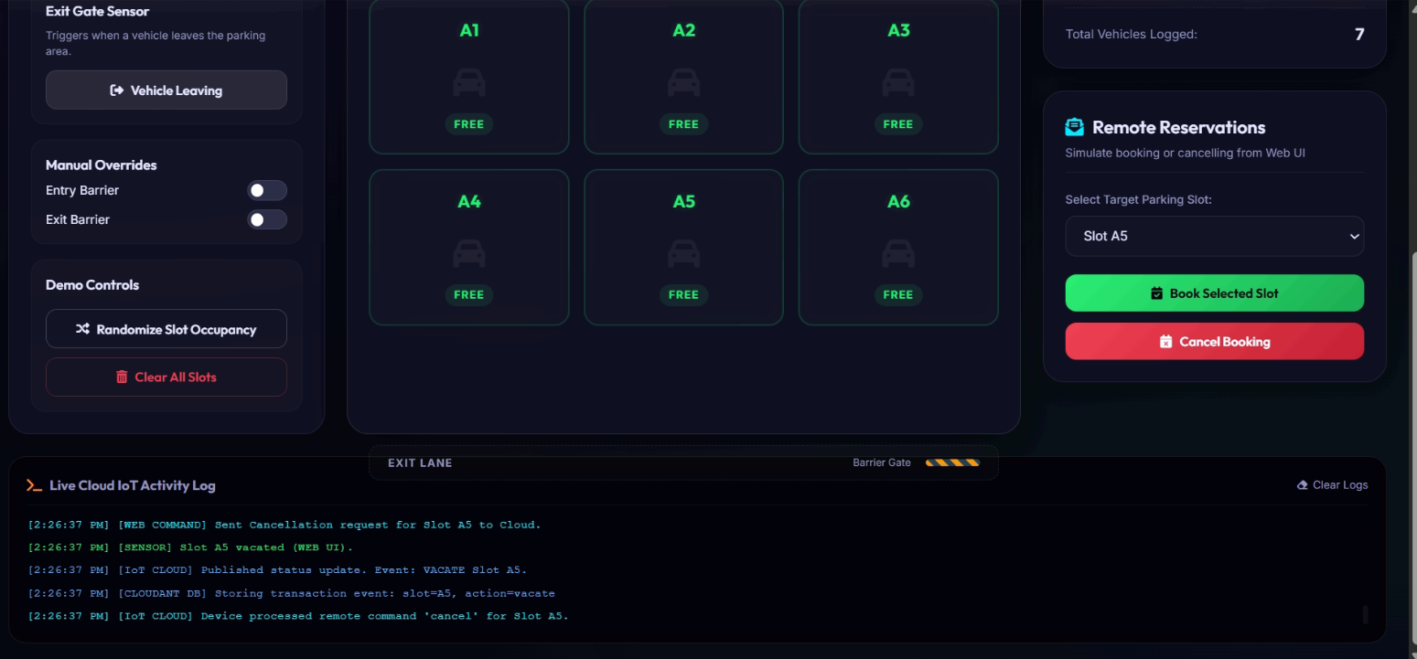


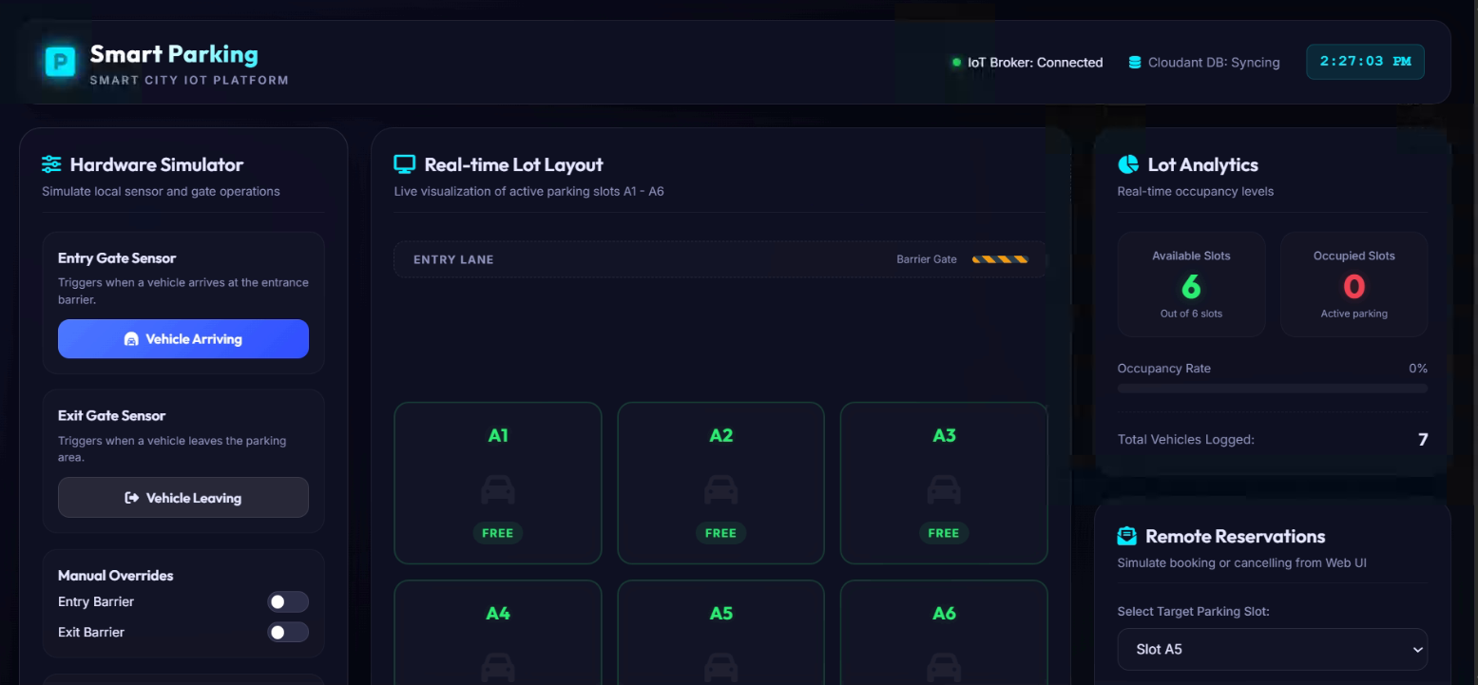
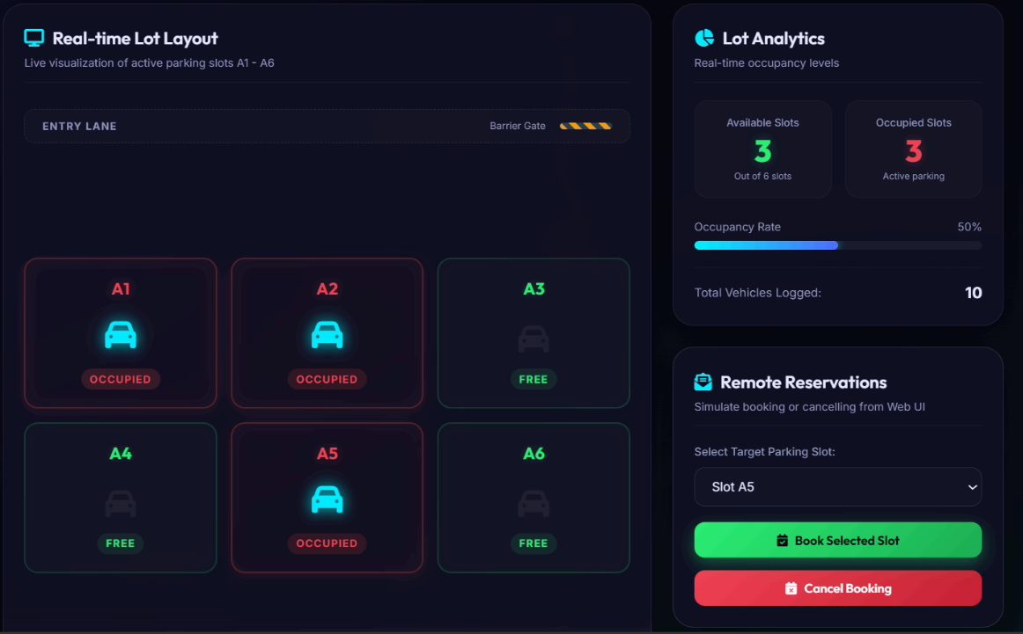
6. Features

- Real-time parking slot monitoring.
- Automatic vehicle entry and exit management.
- Interactive web-based dashboard.
- Live occupancy statistics and graphical analytics.
- Remote parking slot reservation.
- Reservation cancellation functionality.
- Cloud-based data storage and retrieval.
- Event logging and historical data tracking.
- Smart notifications and status updates.
- Offline simulation mode for testing and development.

7. Modules

7.1 Python IoT Agent

- Simulates parking sensors.
- Tracks occupancy status.
- Sends parking data to the cloud platform.
- Receives commands from Node-RED.

7.2 Node-RED Flow

- Processes incoming sensor data.
- Implements parking business logic.
- Connects cloud services and dashboard.
- Handles reservation and cancellation requests.

7.3 Web Dashboard

- Displays available and occupied slots.
- Provides booking and cancellation options.
- Shows occupancy percentage and parking statistics.
- Enables real-time monitoring.

7.4 Cloudant Database

- Stores parking records.
- Maintains reservation history.
- Preserves occupancy statistics.
- Supports data retrieval for analytics.

8. Advantages

- Reduces parking search time.
- Minimizes fuel consumption.
- Lowers traffic congestion.
- Enhances user convenience.
- Supports sustainable urban development.
- Improves parking lot utilization efficiency.
- Provides accurate real-time information.
- Enables centralized parking management.
- Easily scalable for large parking infrastructures.

9. Applications

- Smart City Infrastructure
- Shopping Malls and Commercial Complexes
- Airports and Transportation Hubs
- Railway Stations
- Educational Institutions
- Corporate Offices and Campuses
- Hospitals and Healthcare Facilities
- Residential Apartments
- Event Venues and Stadiums
- Public Parking Facilities

10. Future Scope

The system can be further enhanced with advanced technologies such as:

- Artificial Intelligence for parking demand prediction.
- Machine Learning algorithms for occupancy forecasting.
- Mobile application integration for users.
- QR code-based parking reservation and access control.
- Automatic online payment gateway integration.
- License Plate Recognition (LPR) for automated vehicle identification.
- Smart navigation to guide drivers to available slots.
- SMS and mobile notifications.
- Electric Vehicle (EV) charging station integration.
- Large-scale deployment across smart city ecosystems.

11. Conclusion

The Smart Parking System demonstrates the successful implementation of IoT, cloud computing, and web technologies for efficient parking management. By providing real-time monitoring, automated parking operations, remote booking facilities, and analytical insights, the system significantly improves parking efficiency and user experience. The solution contributes to reduced traffic congestion, optimized resource utilization, and smart city development. With future enhancements such as AI-based prediction and automated payment systems, the project has strong potential for large-scale deployment in modern urban environments.

LINKS:
- GitHub
- Demo

